PoC Description: WeSort.AI GmbH

1. Project Outcome (The Goal) The primary goal of this PoC is to demonstrate that complex, multi-material products from Knorr-Bremse (e.g., electronic braking units) can be automatically separated into high-purity fractions. We aim to prove that these recovered materials meet the quality standards required for re-entry into the production cycle, effectively turning industrial waste back into a strategic resource.
2. Step-by-Step Implementation (The Process)
- Phase 1: Requirement engineering (Month 1): Joint workshop to define target products, material specifications, and KPIs for purity and recovery rates.
- Phase 2: Shredding & material preparation (Month 2): Identification of the ideal mechanical pre-treatment. We test different shredding methodologies to ensure optimal liberation of individual components without destroying valuable fractions.
- Phase 3: AI training & sensor calibration (Month 2-3): Feeding Knorr-Bremse specific component data into our AI. We calibrate our patented sensor fusion (Optical and X-Ray) to recognize the specific alloys and plastics used in your products.
- Phase 4: Industrial Sorting Trials (Month 3): High-speed sorting of the shredded batches in our tech center (500 kg/h) to generate pure fractions of copper, aluminum, and high-tech plastics.
- Phase 5: Validation & Deep Dive (Final 6 Weeks): Intensive laboratory analysis of the output. We verify purity levels and document the consistency of the sorting results.
- Phase 6: Final Presentation & Scaling Roadmap (End of October): Delivery of a comprehensive business case, showing how this solution can be integrated into your global supply chain.
3. Strategic benefits (The Value)
- Resource sovereignty: By recovering critical raw materials from your own products, you reduce dependency on volatile global markets and third-country imports.
- Future competitiveness: Directly fulfill the requirements of the European Critical Raw Materials Act and the ELV Directive, positioning Knorr-Bremse as a leader in circularity.
- Carbon footprint reduction: Recycled materials require significantly less energy than primary mining, directly contributing to your corporate sustainability goals.
- Economic value: Transform disposal costs into revenue by recovering high-purity metals and components that can be sold or reused as high-value feedstock.
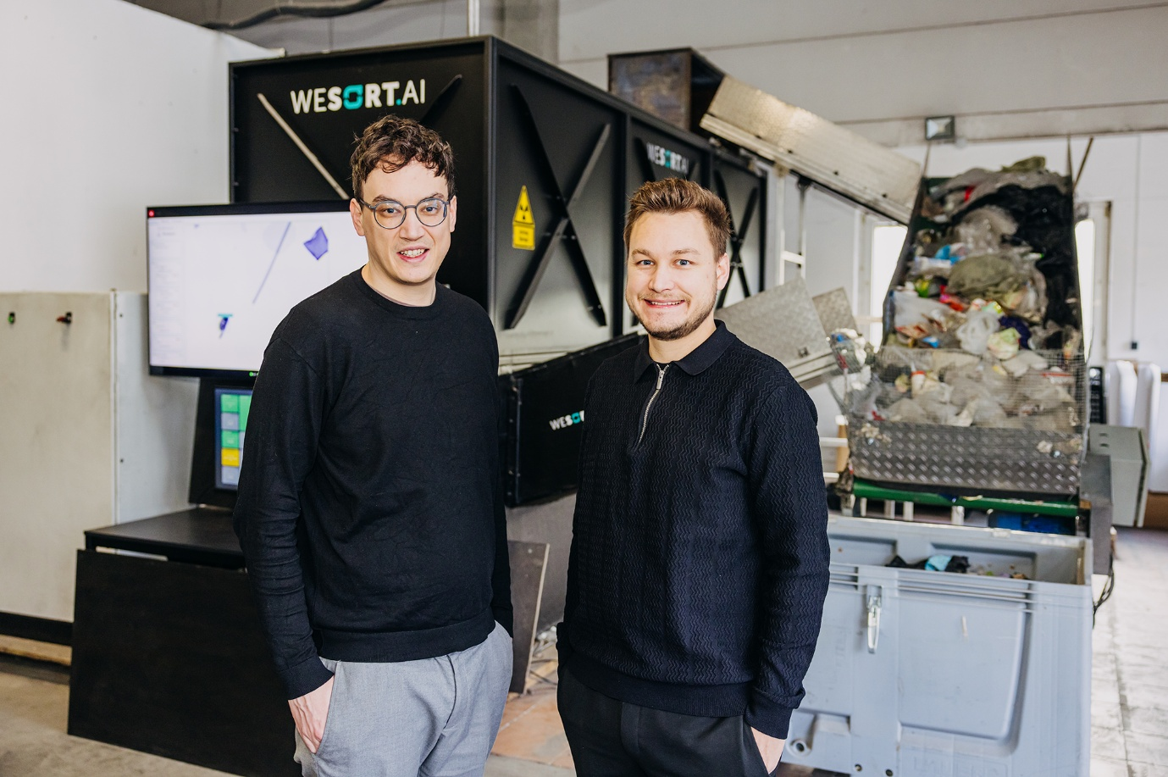(From left to right: Founders Johannes Laier and Nathanel Laier in front of one of our products)
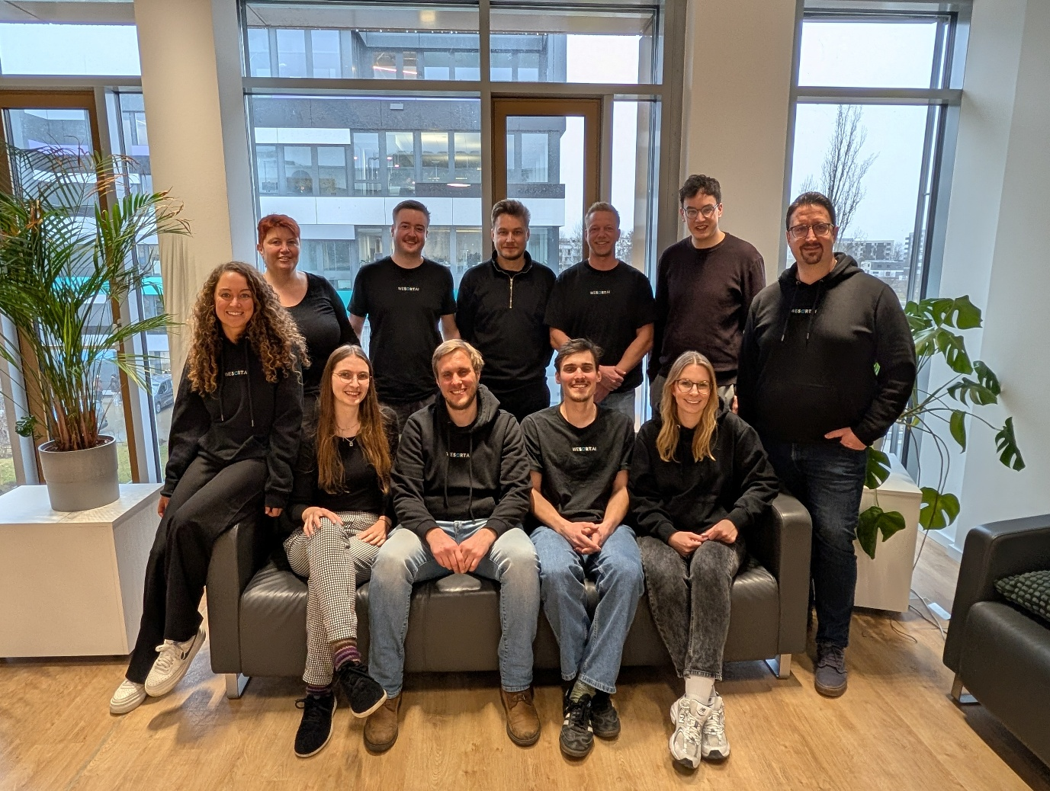(WeSort.AI team based in Wuerzburg)
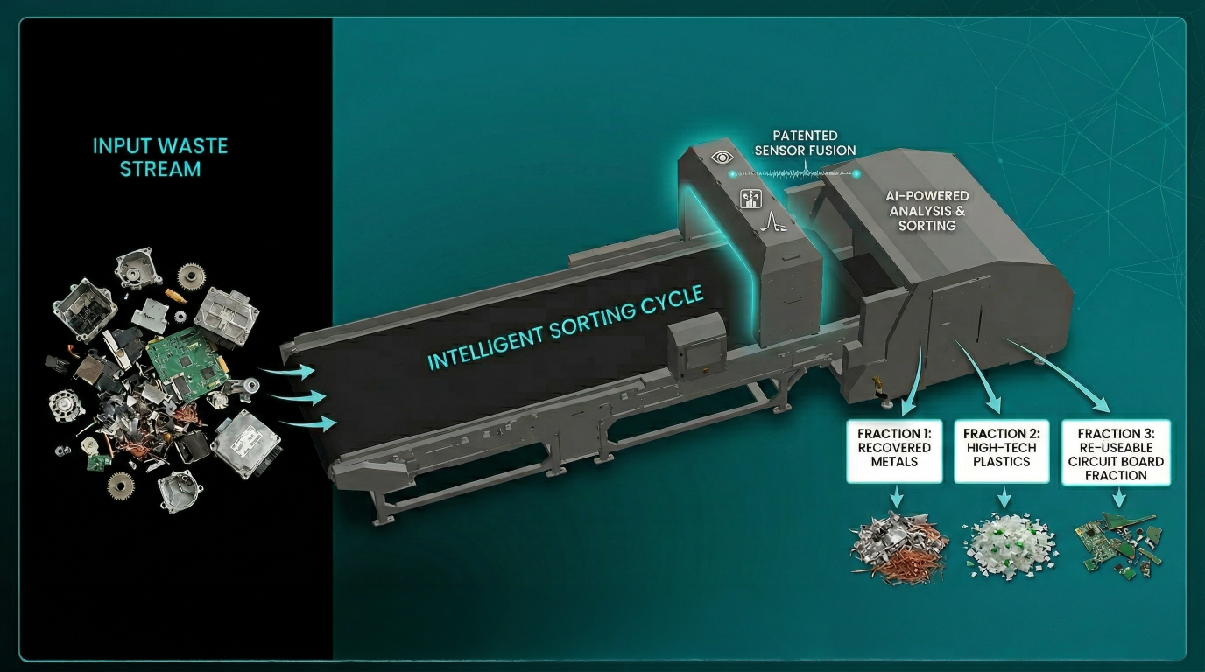(Sketch of a possible WeSort.AI machine and outcome)

